**Лабораторна робота № 1**

**ПОВТОРЕННЯ ООП. ГРА “ХРЕСТИКИ-НУЛИКИ”**

**Мета:** згадати принципи ООП, написати цікаву консольну гру.

**Хід роботи:**

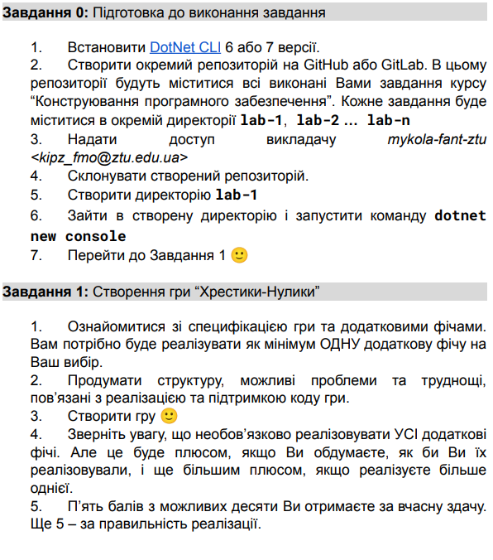

# 

# 

# Результат виконання програми:

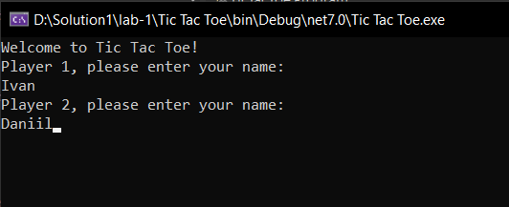

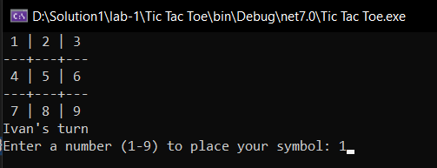

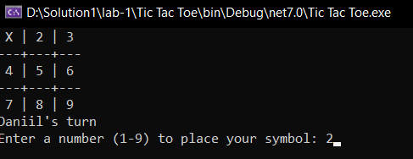

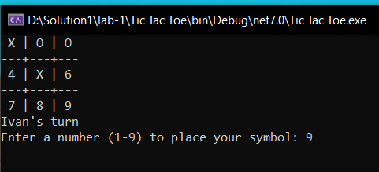

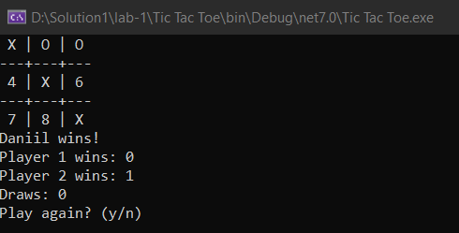

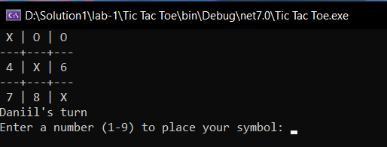

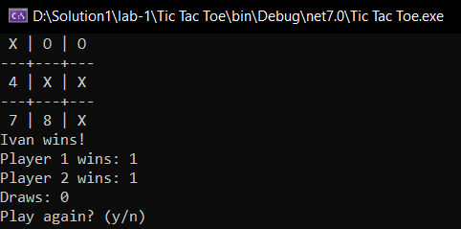

Рис.1.1-7. Реалізація гри Крестики-нулики.

# Лістинг коду:

using System;

namespace TicTacToe

{

class Program

{

static char[,] board = new char[3, 3];

static int turns = 0;

static bool playAgain = true;

static int player1Wins = 0;

static int player2Wins = 0;

static int draws = 0;

static void Main(string[] args)

{

while (playAgain)

{

ResetBoard();

turns = 0;

Console.WriteLine("Welcome to Tic Tac Toe!");

Console.WriteLine("Player 1, please enter your name:");

string player1Name = Console.ReadLine();

Console.WriteLine("Player 2, please enter your name:");

string player2Name = Console.ReadLine();

char player1Symbol = 'X';

char player2Symbol = 'O';

Console.WriteLine("{0} is {1} and {2} is {3}", player1Name, player1Symbol, player2Name, player2Symbol);

bool gameEnd = false;

while (!gameEnd)

{

DrawBoard();

if (turns % 2 == 0)

{

Console.WriteLine("{0}'s turn", player1Name);

Play(player1Symbol);

}

else

{

Console.WriteLine("{0}'s turn", player2Name);

Play(player2Symbol);

}

if (CheckWin() || CheckDraw())

{

gameEnd = true;

DrawBoard();

if (CheckDraw())

{

Console.WriteLine("It's a draw!");

draws++;

}

else

{

if (turns % 2 == 0)

{

Console.WriteLine("{0} wins!", player1Name);

player1Wins++;

}

else

{

Console.WriteLine("{0} wins!", player2Name);

player2Wins++;

}

}

Console.WriteLine("Player 1 wins: {0}", player1Wins);

Console.WriteLine("Player 2 wins: {0}", player2Wins);

Console.WriteLine("Draws: {0}", draws);

Console.WriteLine("Play again? (y/n)");

string answer = Console.ReadLine().ToUpper();

if (answer == "Y")

{

gameEnd = false;

playAgain = true;

if (player1Symbol == 'X')

{

player1Symbol = 'O';

player2Symbol = 'X';

}

else

{

player1Symbol = 'X';

player2Symbol = 'O';

}

}

else if (answer == "N")

{

gameEnd = true;

playAgain = false;

}

}

}

}

}

static void ResetBoard()

{

board = new char[3, 3]

{

{'1', '2', '3'},

{'4', '5', '6'},

{'7', '8', '9'}

};

}

static void DrawBoard()

{

Console.Clear();

Console.WriteLine(" {0} | {1} | {2} ", board[0, 0], board[0, 1], board[0, 2]);

Console.WriteLine("---+---+---");

Console.WriteLine(" {0} | {1} | {2} ", board[1, 0], board[1, 1], board[1, 2]);

Console.WriteLine("---+---+---");

Console.WriteLine(" {0} | {1} | {2} ", board[2, 0], board[2, 1], board[2, 2]);

}

static void Play(char symbol)

{

bool validInput = false;

while (!validInput)

{

Console.Write("Enter a number (1-9) to place your symbol: ");

string input = Console.ReadLine();

if (int.TryParse(input, out int number))

{

if (number >= 1 && number <= 9)

{

int row = (number - 1) / 3;

int col = (number - 1) % 3;

if (board[row, col] != 'X' && board[row, col] != 'O')

{

board[row, col] = symbol;

validInput = true;

turns++;

}

else

{

Console.WriteLine("That cell is already taken, try again.");

}

}

else

{

Console.WriteLine("Invalid input, please enter a number between 1 and 9.");

}

}

else

{

Console.WriteLine("Invalid input, please enter a number.");

}

}

}

static bool CheckWin()

{

// Check rows

for (int row = 0; row < 3; row++)

{

if (board[row, 0] == board[row, 1] && board[row, 1] == board[row, 2])

{

return true;

}

}

// Check columns

for (int col = 0; col < 3; col++)

{

if (board[0, col] == board[1, col] && board[1, col] == board[2, col])

{

return true;

}

}

// Check diagonals

if (board[0, 0] == board[1, 1] && board[1, 1] == board[2, 2])

{

return true;

}

if (board[0, 2] == board[1, 1] && board[1, 1] == board[2, 0])

{

return true;

}

return false;

}

static bool CheckDraw()

{

return turns >= 9;

}

static char Symbol(char symbol)

{

if (symbol == 'X' || symbol == 'O')

{

return symbol;

}

return ' ';

}

}

}

**Висновок:** на лабораторному занятті я згадати принципи ООП та написав цікаву консольну гру.